**Chapter 5 Preliminary questions Answers!**

Type out your own personal answers to the following questions! Keep a folder of all the work you accomplish during this period.

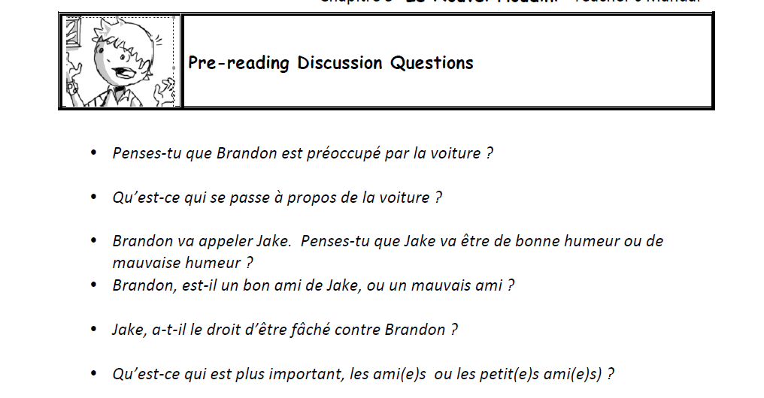

Answers may vary!

1. Example: Penses-tu que Brandon est preoccupe par la voiture? ‘ Oui parce qu’il ne veut pas manger.

2.

3

4

5.

6.

FYI more items below

Chapter 5 Questions (Answer in English)

1. What problem does Brandon need to resolve?

Needs to clean up the ketchup in his dad’s car.

1. Whom does Brandon call to help solve this problem?

Jake

1. Why Jake is mad?

Because Brandon is with Marianne.

1. Why does Brandon’s grandmother call to him?

It is time to eat (A table)

1. What suggestion does Jake give about cleaning up the ketchup?

Use vinegar

1. What excuse does Brandon give for needing vinegar?

School project

1. What two odors exist now in the car?

Ketchup/vingar

1. What does Jake suggest, in order to solve this problem?

carwash

1. How much does this service cost? $200

Chapter 5 Questions (Answer in French)

1.Il faut nettoyer l’interior la voiture.

2.Il telephone a Jake.

3.Parce que Brandon etait avec Marianne.

4.Elle l’appelle pour manger.

5. Il suggere de utiliser le vinaigre.

6.Il lui a dit que le vinaigre est pour un projet

7.vinaigre

8.Belle Voiture

9.Ca coute $200.

1.

2.

3.

4.

5.

6.

7

8

9

